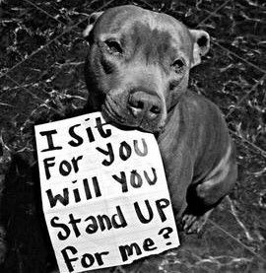
Animal Welfare
(Month of May/ ORANGE/ could do the drive in December though)
- Have a towel drive
  - People donate gently used towels for dog shelters
  - Also donate toys
- Pitbull Ban
- Hang up posters to encourage fostering of dogs/ cats
  - Encourage people to rescue
  - Hang up profiles and pros of rescuing
- Fundraiser?
- Veteran dogs?
- Having animals get sprayed or neutered to prevent overpopulation
  - Reduce the number of strays
  - Possible bill?
    - Research laws/ regulations surrounding this topic

