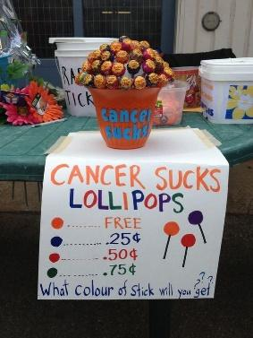
Other Ideas
- Appreciation
  - Video
  - Appreciate family
  - Do something for staff appreciation or custodian appreciation?
  - appreciating police officers
- Period Awareness
  - make people understand that people shouldn’t be ashamed about periods
  - how girls can get access to education on periods
  - Period Tax- why is there a tax!!!
  - Periods and the homeless
- Teen suicide
- Mental illness
  - Possibly write letter to patients on Valentines day etc. to show our support
- Alzheimer’s
  - Fundraising events
- Children of War/ Refugees
  - Art supplies / art activity
  - coloring books? art is therapeutic
  - https://www.britishcouncil.org/voices-magazine/how-art-helped-these-children-traumatised-war
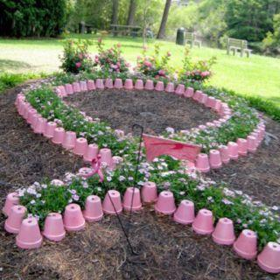
- Pink out
  - For breast cancer awareness
- Something about body shaming? /Self Love and Appreciation
  - Eating disorders etc.
- Social Media Campaign
  - Post pictures and information
  - Pictures of us holding posters with sayings
- Big poster with sticky notes
- Kids whose parents are divorced
  - helping them
- Advocating creativity in schools
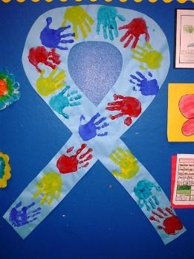
Awareness projects will be conducted based on the themes during each month. Some examples of topics are: poverty, homelessness, food waste, hunger, plastic straw consumption, autism, alzheimer's, parkinson's disease, driving safety, down syndrome, animal welfare/shelters, cancer, conserving energy, children of war/refugees, AIDS, and various other social topics.

