Poverty/ Homelessness Awareness
January is poverty awareness month/ November is homelessness awareness month (red or purple)
- Posters with facts / something with food waste
  - Set up a visual (look at side)
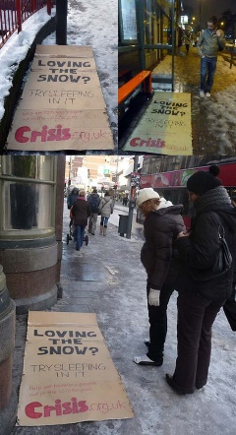
- Sock drive
  - Collect socks the month of November for the homeless
- Tampon Drive?
  - Do something with the homeless and periods
  - Collecting toiletries
- Visual representation
  - http://www.candidslice.com/a-lesson-plan-for-childhood-poverty-and-chocolate/
  - Activity with candy for people to see the facts
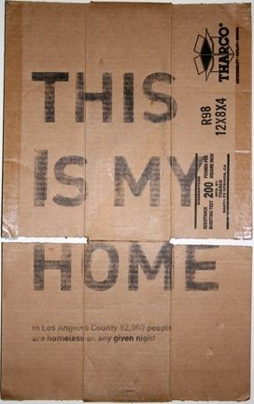
  - Have a jar of candies in the front lobby with __ # of candies to represent people in poverty / have people donate to win the jar of candy
- Picture books on poverty
  - Set up display at the library
  - https://www.whatdowedoallday.com/picture-books-about-poverty-homelessness-and-hunger/
- #nokidhungry
  - Something with meals/ food for homeless
  - Pack backpacks full of food for kids to take home over the weekend

