Sexual Assault Awareness / Domestic Violence
(The month of April/ TEAL) – October is Domestic Violence (PURPLE), so we could something similar since April is both sexual assault and Autism awareness month.
** To get some of the supplies- we will have to do some club fundraising
- Denim Day
  - Some day in April
  - Everyone wears jeans or denim to show support
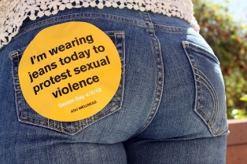
  - Put in announcements and hang up flyers
  - Advertise through social media
  - Hand out the stickers
- Letter to senator
** SEX Ed in general
  - Talk about sexual assault
  - Need for education on sexual assault in school
    - Go around school and middle school and ask about curriculum and see what is included
    - Speak to health class (high school and middle school)
  - Bill to have sexual assault/ rape apart of health education curriculum (mandatory in schools)
  - Help spread awareness and end stigmatism surrounding sexual assault
- Media Center Display Case
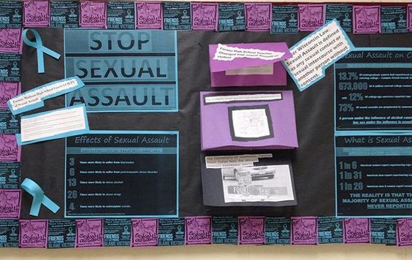
  - Have books that talk about sexual assault
  - Decorate it (with teal and awareness ribbons etc.)
- Create posters or decorate bulletin board
  - Restroom Campaign
    - Hang up posters in the bathrooms
  - Include facts
  - There are no blurred lines when it comes to rape
  - CREATE A CULTURE OF CONSENT
- Letter home to parents
  - Talking about sexual assault
  - Consent
  - Have them talk to their kids about it
- Hand out ribbons
  - Teal or white
  - Also hand out tattoos w/ believe the survivor change the culture
  - No means no
  - Your voice has power- speak out against the abuse
- Awareness tables
  - Set up at stores or library
  - Brochure and info
  - Pins/ ribbons
- Host informational speaking event? After school or at library
  - Kahoot with facts???
- Decorate the front office
  - Hang up streams that are teal to rep. awareness
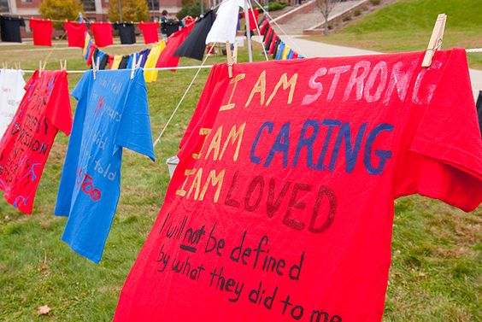
- Decorate shirts
  - Activity at library
  - Display around park or around school
  - https://www.flickr.com/photos/collegeatbrockport/8595257303/in/photostream/
- Segment in newspaper/ adams kilt

